**Domain Model and Class Diagram**

**Ex No :**

**Date :**

**Aim:**

To identify the classes and their associations and draw domain model and class diagram for Attendance Management System.

**Notations for domain model :**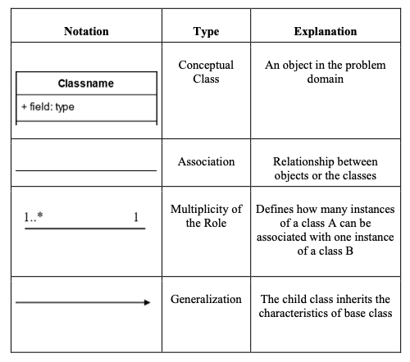

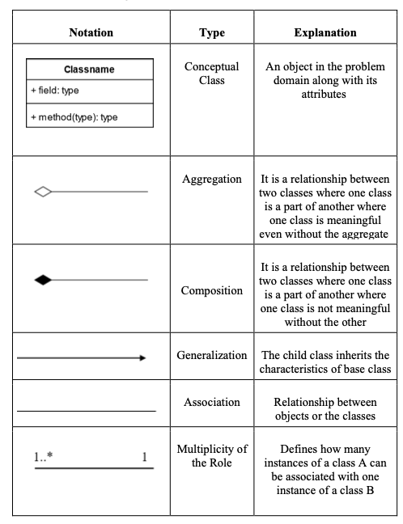

**Identification of Classes:**

| Conceptual Class Category | Conceptual Class |
| --- | --- |
| Physical or Tangible object | Attendance record, Course |
| Specifications | Course Description |
| Roles of People | User: Students, Teachers, Admin |
| Events | Marking attendance, Applying for OD,  Raising Ticket. |

**Identification of Noun Phrases:**

**Initial list of noun phrases:**

* Student
* StudentDescription
* Admin
* AdminDescription
* Teacher
* TeacherDescription
* Attendance
* OD
* Subject
* Subject Name
* Subject Code
* Student ID
* Teacher ID
* Email
* ODProof
* Date
* Period

* **Final List of Noun Phrases:**
* Student
* StudentDescription
* Admin
* AdminDescription
* Teacher
* TeacherDescription
* Attendance
* OD
* Subject

**Identification of Association:**

1. **Identification of Association**

| **Category** | **Association** | **Between** |
| --- | --- | --- |
| A is logically contained in B | PartOf | Student and Subject |
| A is logically contained in B | PartOf | Teacher and Subject |
| A manages B | Manages | Admin and Teacher |
| A manages B | Manages | Admin and Student |
| A is an event related to B | Marks | Attendance and Teacher |
| A is an event related to B | Views | Attendance and Student |
| A is an event related to B | Applies | OD and Student |
| A is an event related to B | Verifies | OD and Teacher |
| A is item description of B | Describes | StudentDescription and Student |
| A is item description of B | Describes | TeacherDescription and Teacher |
| A is logically contained in B | Consists | Subject and Attendance |
| A is an event related to B | Updates | OD and Attendance |

1. **Definition of Association**

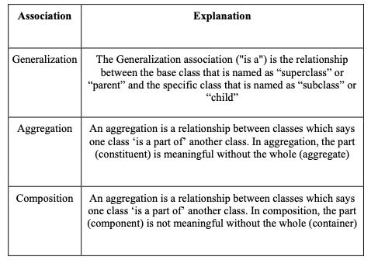

1. **Multiplicity**

| **Relationship** | **Multiplicity** |
| --- | --- |
| Student and Subject | One or more students (1..*) can be a part of one or more subjects (1..*) |
| Teacher and Subject | One teacher (1) can be a part of one or more subjects (1..*) |
| Admin and Teacher | One admin (1) can manage one or more teachers (1..*) |
| Admin and Student | One admin (1) can manage one or more students (1..*) |
| Attendance and Teacher | One teacher (1) can mark one or more attendances (1..*) |
| Attendance and Student | One student (1) can view one or more attendances (1..*) |
| OD and Student | One student (1) can apply for one or more ODs (1..*) |
| OD and Teacher | One teacher(1) can verify one or more ODs (1..*) |
| StudentDescription and Student | One student (1) can describe one student (1) |
| TeacherDescription and Teacher | One teacher (1) can describe one teacher (1) |
| Subject and Attendance | One subject (1) can consist one attendance (1) |
| OD and Attendance | One OD (1) may or may not update one attendance (0..1) |

**Domain Model Diagram:**

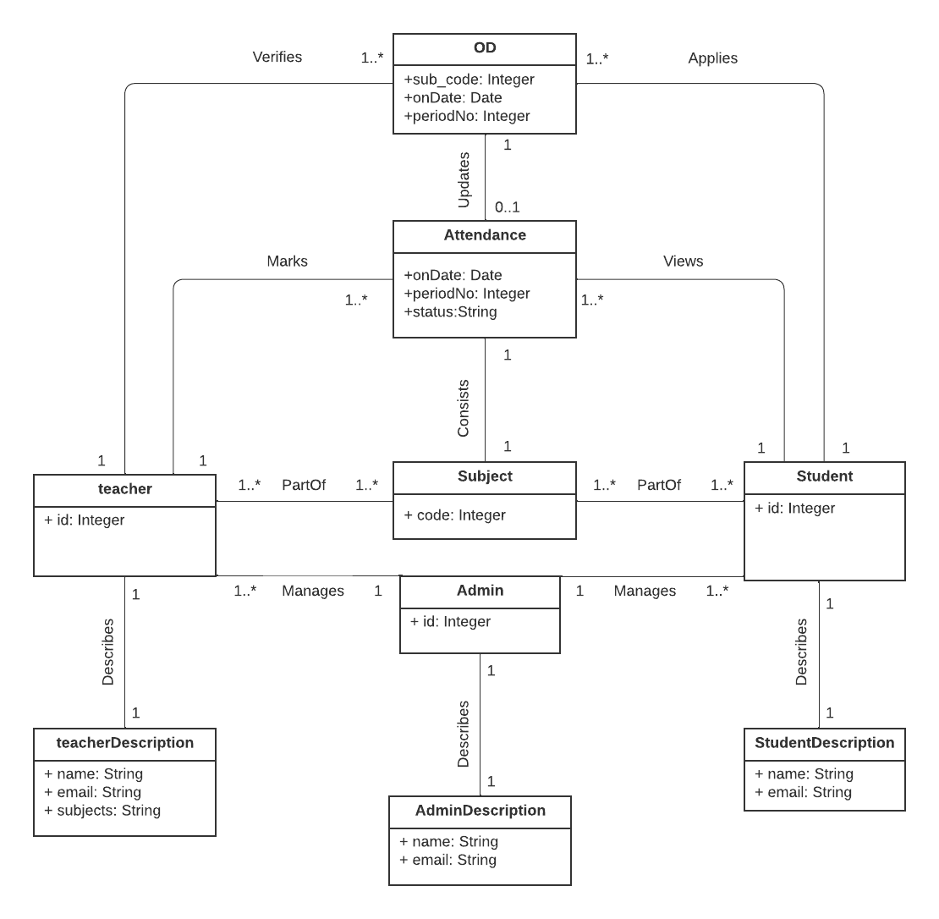

**Class Diagram:**

